PRESS RELEASE FOR IMMEDIATE USE | 07.07.2026

Cast announced for Dominic Hill's touring production of Orwell's 1984

29 August – 26 September | Citizens Theatre
30 September – 10 October | Dundee Rep Theatre
13 October – 17 October | His Majesty's Theatre, Aberdeen
27 October – 07 November | The Royal Lyceum Theatre Edinburgh

Press night: 3 September

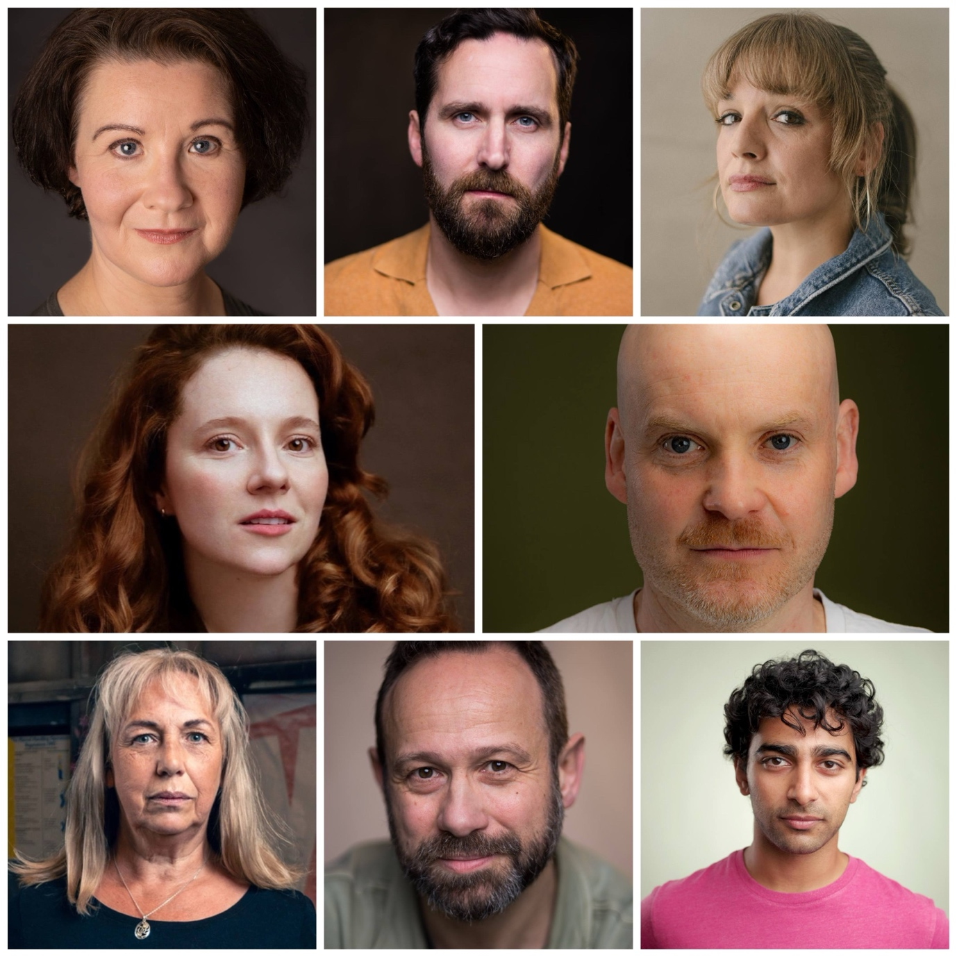
The cast has been announced for 1984, a new adaptation of George Orwell's dystopian classic, adapted by Chris Hannan and directed by Dominic Hill. This co-production between Citizens Theatre, Dundee Rep Theatre and The Royal Lyceum Theatre Edinburgh opens in Glasgow on 29 August before touring across Scotland
One of the defining novels of the 20th century, Orwell’s 1984 is a chilling vision of a society built on fear and the manipulation of truth. At its heart is the story of Winston Smith and Julia, whose dangerous love affair sparks an act of rebellion in a world designed to crush hope.
Dominic Hill, Artistic Director of the Citizens Theatre and director of 1984 said: "Theatre is at its most exciting when it brings audiences together to confront urgent ideas, and there are few stories more compelling than 1984. Chris Hannan has created a thrilling adaptation that is both intimate and epic, and this remarkable company of actors will bring extraordinary humanity to Orwell's unforgettable characters. We're delighted to be sharing this production with audiences across Scotland."
Today, the full cast for 1984 is announced.
Jack Tarlton takes on the role of Winston Smith, the everyman at the centre of Orwell’s dystopian world. Tarlton is widely recognised for screen roles including Kenny Lindsay in Outlander, Fiscal John in Traces and appearances in The Imitation Game and Doctor Who. His stage work includes performances with leading UK theatres including the National Theatre.
Opposite him, Jessica Hardwick plays Julia. A familiar face to Scottish audiences, Hardwick has appeared in many acclaimed productions including Gush (Traverse Theatre), Two Sisters (The Royal Lyceum Theatre Edinburgh), The Comedy of Errors (Citizens Theatre) and Crime and Punishment which was a Chris Hannan and Dominic Hill production. On screen, her credits include Float, Hijack, Payback and Shetland, and she is a Critics’ Awards for Theatre in Scotland Best Female Performance winner in 2026.
Also joining the company is Irene MacDougall as O’Brien. A longstanding member of the Dundee Rep Ensemble, MacDougall has enjoyed an extensive career across Scottish theatre, with major roles in productions including Who’s Afraid of Virginia Woolf? (CATS Best Actress winner), Death of a Salesman, The Glass Menagerie and August: Osage County. She is also a founder member of Stellar Quines and has worked widely in television and radio.
Performing in multiple roles alongside them are:
Irene Allan (Mrs Syme/Mrs Ogilvy/Mother/Nurse Rankine), whose screen work includes Bite Size Halloween and Not Safe for Work; Neshla Caplan (De Souza/Thought Policewoman/PE Instructor), known for television roles in Rebus, Scot Squad and Amazon Prime’s The Rig; Robert Jack (Syme/Dr Dick) who returns to the Citizens Theatre following his appearance in the landmark reopening production Small Acts of Love and most recently, The Long Drop; Peter Collins (Parsons/Charrington), an established stage performer across Scottish theatre who recently appeared in a hit children’s show, Snowy and Zrey Sholapurkar (Comrade Ogilvy/Thought Policeman/Sean/Nurse), a versatile performer working across stage and screen who recently starred in Bryn Holding’s Lark Rise to Candleford.
1984 is a powerful, urgent retelling of Orwell’s masterpiece, bringing one of the most influential novels of modern times to the stage in a gripping new production that speaks directly to our times.
/ENDS

Notes to editors:

Citizens Theatre, 29 Aug -26 September
citz.co.uk

Dundee Rep Theatre, 30 September – 10 October
dundeerep.co.uk

His Majesty's Theatre, Aberdeen, 13 October – 17 October
aberdeenperformingarts.com/his-majestys-theatre/

The Royal Lyceum Theatre Edinburgh, 27 October – 07 November
lyceum.org.uk

For media enquiries please contact:
Magda Paduch, Premier | magda.paduch@premiercomms.com

For Citizens Theatre company enquiries, please contact:
Louise Dingwall, Press and Marketing Officer: louisedingwall@citz.co.uk (Mon - Thurs)
Alison Lewis, Marketing Manager: alison.lewis@citz.co.uk

Citizens Theatre
The Citizens Theatre is Glasgow’s major producing theatre and one of the UK’s most influential theatre companies. Celebrated internationally for its bold, groundbreaking productions, the theatre also champions pioneering participatory and community programmes. Co-led by Executive Director Kate Denby and Artistic Director Dominic Hill - hailed by the Daily Telegraph for “a talent for classical drama which is genuinely world class” - the Citizens Theatre presents bold new interpretations of classic texts alongside new writing.

Rooted firmly in the Gorbals, at the heart of Glasgow’s cultural life, the theatre combines a deep local connection with an international outlook. After an extensive redevelopment, the Citizens Theatre proudly reopened its doors on 23 August 2025, offering an exciting new chapter in its celebrated history.

citz.co.uk

The Royal Lyceum Theatre Edinburgh
At The Royal Lyceum Theatre Edinburgh, we create outstanding theatre for Edinburgh and the world.

From our 140-year-old home in the heart of the city, we welcome over 100,000 people each year. Under the leadership of Artistic Director James Brining, we present world-class productions and champion Scottish theatre on the global stage.

We’re experts in making theatre. We rehearse in our studio space across the road from the auditorium, and our costumes and sets are designed and built in house at our workshop in Roseburn, Edinburgh.

Our creative passion extends into our community and engagement efforts. Our Youth Theatre has been the starting point for many Scottish actors, fostering newfound confidence and lifelong friendships. We also host writing and acting groups for people aged 60+, technical courses, and training opportunities for theatre artists at different stages of their career.

Over the past 60 years The Lyceum has continued to make world class theatre – take a seat and experience it for yourself.

lyceum.org.uk
Box Office: 0131 248 4848 / boxoffice@lyceum.org.uk

Dundee Rep
Driven by the belief that creative experiences are essential to life, we have been crafting meaningful human connections through the arts for nine decades. Our story is one of people: artists, creatives, staff, participants, and audiences. Our mission is driven by a commitment to being welcoming, collaborative and always learning from people and experiences.
Nestled in the cultural heart of Dundee, we stand as Dundee’s heartbeat of creativity. Together, Dundee Rep Theatre and Scottish Dance Theatre create and present works for local, national, and international audiences, with education at our core. Dundee Rep Theatre, a leading force in Scottish theatre, has produced numerous acclaimed and award-winning productions, including the 2025 premiere of Make It Happen, co-produced with National Theatre of Scotland and Edinburgh International Festival, the Scottish premiere of the Pulitzer Prize-winning August: Osage County, the Scotsman Fringe First winner and Musical Theatre Review’s Best Musical at Edinburgh Fringe 2024 A History of Paper, the world premieres of musicals No Love Songs and Oor Wullie, and the 80th Anniversary season world premiere of Peter Arnott’s Tay Bridge.
Scottish Dance Theatre, founded as a grassroots community company in 1986, has evolved into Scotland’s flagship contemporary dance company. Rooted in Dundee, a city with a proud industrial heritage and surrounded by nature, farming, and fishing communities, we are dedicated to our art form and the people we share it with. We collaborate with artists worldwide, bringing our work to remote village halls in the Scottish Highlands, opera houses in South America, art festivals in Europe, and local schools, prisons, and shopping centres.
At Dundee Rep and Scottish Dance Theatre, we believe high-quality artistic and creative experiences should be accessible to all. Our dedicated Engage team builds local and national partnerships, fostering learning, creativity and community performance. For 30 years, we have been one of only two UK theatres providing dramatherapy for adults and families, offering therapeutic mental health support in a creative, non-clinical environment.
Our impact is profound and far-reaching, extending locally, nationally, and internationally. Together, we are bringing Dundee to the world, shaping a vibrant cultural landscape that celebrates the power of the arts to transform lives and foster meaningful connections.

dundeerep.co.uk

